Deirkifa high school couting(arrangement and combination) date: /1/2024
Name: ...................................................... grade: 12 (L.S) (G.S)

A) n factorial:
Example: 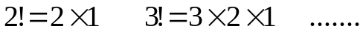
By convention: 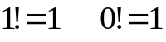
Note that:
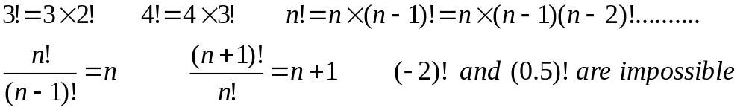
B) Arrangement with repetition or P-list:
Let E be a finite set containing n elements. Let p. An arrangement with repetition of p elements (p by p) out of a set E is an ordered choice (sequence) of p elements of E distinct or not.
Example1: Let 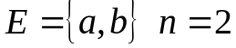.
a) Give all the arrangements taken 2 by 2 out of E (with repetition) or find 2 lists of E.
b) Give the total number of arrangements taken 3 by 3 out of E (with repetition).
Example2: Let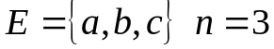
Give the total number of arrangements taken 4 by 4 out of E (with repetition).
General Case: An arrangement with repetition of p elements (p by p) out of a set E containing n elements or the p list of E is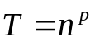.

C) Arrangement without repetition:
Let E be a finite set containing n elements. Let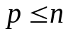. An arrangement p to p without repetition out of the set E is an ordered choice of p distinct elements of E.
Example1: Let
Give the total number of arrangements taken 2 by 2 without repetition out of E using 2 methods.
Example2: Let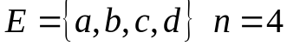
Give the total number of arrangements taken 3 by 3 without repetition out of E.
General case: E is a finite set of n elements. Find the total number of all arrangements taken p by p out of the set E without repetition
n | n-1 | n-2 | n-3 | ..............................................

P boxes
For p=2, 2 by 2, T=n(n-1)=n(n-2+1)
For p=3, 3 by 3, T=n(n-1)(n-2)=n(n-1)(n-3+1)
For p=4, 4 by 4, T=n(n-1)(n-2)(n-3) =n(n-1)(n-2)(n-4+1)
.
.
For p=p, p by p, T=n(n-1)(n-2)(n-3)...........(n-p+1)
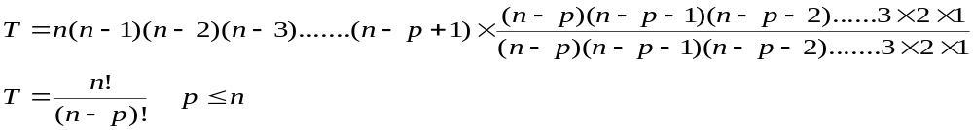
Notation: We denote by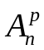 the total number of arrangements taken p by p without repetition out of E where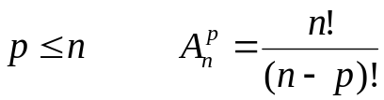

Application1: Calculate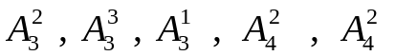
Note: 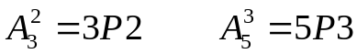
Application2: Let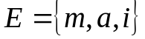. How many distinct letters can be formed using the elements of E.
Application3: Let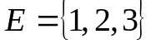.
1) How many 2 digit words can be formed using different numbers from E?
2) How many 3 digit words can be formed using different numbers from E?

C) Permutation:
A permutation is an arrangement without repetition taken n by n out of a set E having n elements
Let p=n, T=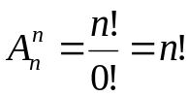 is the total number of the permutations
Example1: Let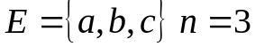. Find the number of permutations of E and write them.
Example2: Let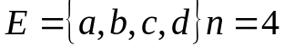. Find the total number of permutations of E.
Example3: Consider the word MAISON. How many words of 6 distinct letters can we form using the letters of the given word without repetition?

Exercise1: Consider the set.
a) How many 3 distinct digit numbers can be formed by using the elements of E. Use two methods.
b) Answer the same question if the repetition is allowed.

Exercise2: Let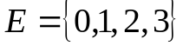
How many 3 distinct digit numbers can be formed by using the elements of E.

Exercise3: How many 3 distinct digit numbers can be formed by using the digits: 0, 1,2, 3 , 4 , 5 , 6 , 7 , 8 , 9?

Combination:
A) Definition:
Let E be a finite set containing n elements. Letwhere p and n are two natural numbers. A combination p to p out of a set E is a non ordered subset of E containing p distinct elements.
Example1: Let .
a) Give all the combinations taken 2 by 2 out of E.
Example2: Let
Give all the combinations taken 3 by 3 out of E.
Note that we have only one combination.
Example3: Let
1) Give the total number of arrangements taken 2 by 2 out of E without repetition.
2) Find the combinations taken 2 by 2 out of E
3) Compare the number of arrangements and that of combinations. What do you notice?
Remarks:
1) In an arrangement, order is considered, while in combinations, order is not important.
2) combination = arrangement/p!
3) In a combination, we can’t use a tree diagram

Example4: Let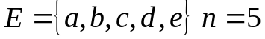.
Find the total number of all combinations taken 3 by 3 out of E using the above rule.
General Case:
Denote by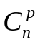the total number of all combinations taken p by p out of E having n elements.
If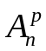 is the total number of arrangements taken p by p without repetition then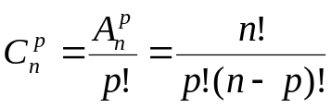

Applications: Calculate 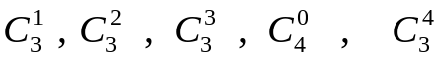
Properties:
1) 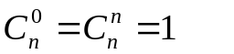
2) 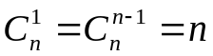
3) 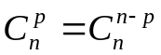 Proof: 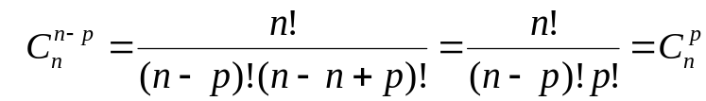
4) Pascal’s Relation: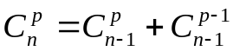
Proof: 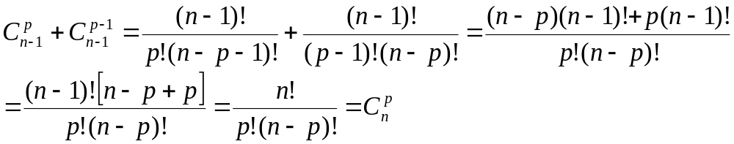

Example: 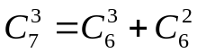 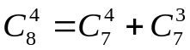

5) Newton’s Binomial Law:
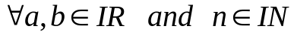, we have:

Where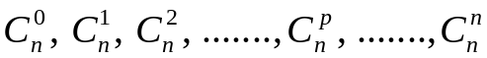are called Newton’s coefficients (n+1) coefficients.

Applications:
1) Calculate 2^{n}.
2) Expand (a+b)³ using Newton’s binomial law.

Remark about the different types of draws:
1) Successively without repetition: Arrangement without repetition: or by boxes
2) Successively with repetition: Arrangement with repetition: p-list or boxes
3) Simultaneously: Combination:

Exercise1: Show that if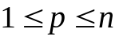then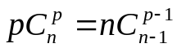

Exercise2: A jar contains 9 balls numbered from 1 to 9.
Given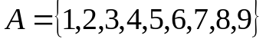
a) 3 balls are successively drawn out each time putting back the chosen ball in the jar. The result is a number formed of 3 digits. What is the number of possible numbers?
b) The balls are now drawn without replacement. What is the number of possibilities?
c) 3 balls are drawn simultaneously. What is the number of possibilities?

Exercise3: A class contains 20 students: 12 girls and 8 boys. 3 students are to be chosen to make a survey.
1) How many groups of 3 students can be formed?
2) How many groups consisting of 3 girls are there?
3) How many groups consisting of 2 boys and 1 girl are there?

Exercise4: 8 balls are placed in an urn, 3 are black, 2 are white and 3 are red.
A) The balls are selected simultaneously.
1) In how many different ways can we make this draw?
2) In how many different ways can we draw 3 balls in which only 2 of them are black?
3) In how many different ways can we draw 3 balls in which at least one is black?
B) 2 balls are simultaneously drawn. In how many ways can we draw 2 balls of same color?

Exercise5: Find the number of words formed of 3 letters by using the letters of word (SES).

Exercise6: Solve in each of the following equations:

Exercise7:
1) Show that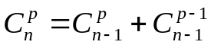 Deduce that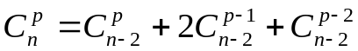
2) Solve in the equation: 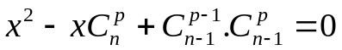

Exercise8:
1) How many numbers can you compose with 3 distinct digits?
2) In how many ways can we arrange n persons?
a) In a line.
b) Around a circular table.

Exercise9:
1) In how many ways can 3 boys and 2 girls sit on a bench?
2) In how many ways can they sit if the boys want to sit next to each other and the same goes for the girls?
3) In how many ways can the girls only sit next to each other?

Exercise10: Calculate each of the following sums:
1) .Deduce the sum: 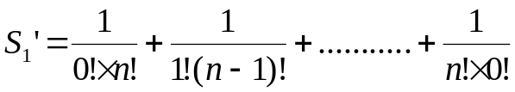
2) 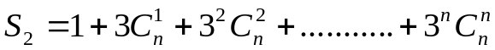
3) 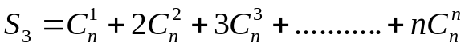

Exercise11: Consider the n points A₁ , A₂ , ...... , A_{n} of the plane such that any three of them are not collinear.
1) How many straight lines can be determined by these points?
2) a- How many triangles can be determined by these points?
b- How many of these triangles contain the point A₁?

Exercise12: Solve in IN the system: 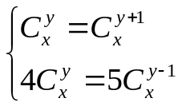

Exercise13:
Use combination to determine the number of rectangles in this figure.

Exercise14: A jar contains 7 balls of which 4 are green, 2 are yellow and one is red. Two balls are drawn simultaneously.
1) Find the total number of drawings?
2) In how many ways can the two selected balls be green?
3) In how many ways can the two selected balls have the same color?
4) In how many ways can the two selected balls be of the same color?

Exercise15: A jar contains 3 white balls, 4 red balls and 2 black balls.
A) 3 balls are drawn successively without replacement.
1) Find the total number of all possibilities.
2) In how many ways can we draw 3 white balls?
3) In how many ways can we draw 3 balls knowing that only the third one is white?
B) 3 balls are now drawn randomly and simultaneously.
1) Find the total number of all possibilities.
2) In how many ways can we draw 3 balls of the same color?
3) In how many ways can we draw 3 balls of different colors?

Exercise16:
A jar contains 4 bills each of 10 000L.L.,2 bills each of 50 000 L.L., and 3 bills of 100 000 L.L.
3bills are drawn simultaneously and randomly.
1) Find the total number of possibilities.
2) In how many ways can the gotten sum of money be 70 000 L.L?
3) In how many ways can the gotten sum of money be 160 000 L.L?
4) In how many ways can the gotten sum of money be 30 000 L.L?

Exercise17:
A committee consists of 44 men and 36 women. Three persons are to be chosen randomly and simultaneously.
1) Find the total number of possibilities.
2) In how many ways can the chosen persons consist of 2 men and 1 woman?
3) In how many ways can the chosen persons be 3 men?
4) In how many ways can the chosen persons consist of at least one boy?

Exercise18: Calculate